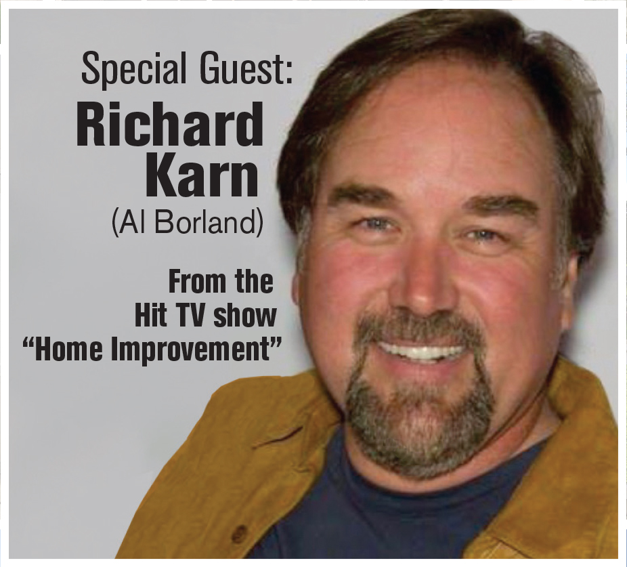

Home Improvement Star comes to The Home Owners Expos

Richard Karn from the TV Show Home Improvement at Spring 2022 Home Expos
Oct. 29, 2021- Richard Karn played the loveable Al Borland alongside Tim Allen in the TV show Home Improvement. His signature phrase, “I don’t think so” became a pop culture sensation. Richard will be at the Show in Wilmington, DE March 5-6, and the UMBC show in Baltimore April 2-3, 2022 to discuss behind the scenes of one of the most popular TV shows in modern history, talk about his own home improvements and more.
And, admission is free for anyone named Al, or if you wear a flannel shirt. (Allens, Alberts, Alices and so forth also qualify)
“We are excited to have our shows back on track for the spring of 2022” , says Scott Smith, President of Mid Atlantic Expos. “Richard draws a great crowd, and everyone loves the guy. It was amazing to see over 600 people wear flannel shirts at a show a few years ago. We are looking forward to kicking things off right in 2022” he added.
For photos and additional information, email us at office@midatlanticexpos.com
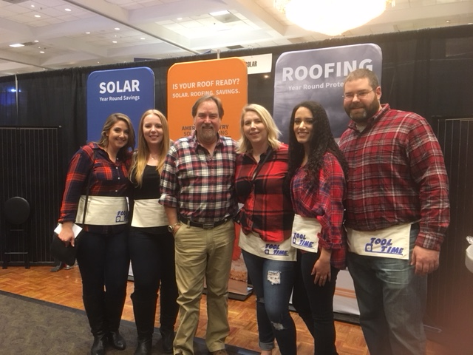
CONTACT INFORMATION:
Scott Smith, Mid Atlantic Expos
410 878 2550
office@midatlanticexpos.com

